**FILE I/O**

Basic File I/O:

* Lots of programming involves using data outside of your actual .py file – it can be read in from Excel spreadsheets, Word documents, PNG images, and infinitely many other file types
* The simplest file type is a text file, with the extension .txt
* Only text data can be stored in text files – if you are familiar with the notepad application on your computer, this is an example of text file creation
* There are a few ways to read in a text file in Python, but the most straightforward method that I typically use is shown in the following image:

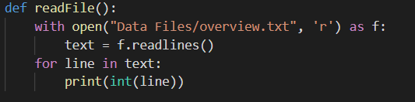

* There are several components involved, but the important parts of reading a text file include:
  + with open(FILEPATH, OPERATION) as FILEVARIABLE:
    - FILEPATH: location of the file being read in based on the python file
    - OPERATION: ‘r’ for read, ‘w’ for write
    - FILEVARIABLE: whatever variable name you want your file operator to be
  + LISTVARIABLE = FILEVARIABLE.readlines()
    - LISTVARIABLE: becomes a list where each value in the list is the text of a line of the file, in order
  + The for loop then iterates through each entry in the list and prints it
    - Note the int(), which is used because text files are automatically read as strings and will need to be converted
* In addition to the base syntax, Python also has several additional packages that are part of the Python Standard Library – these can be initialized using an import statement at the top of the file

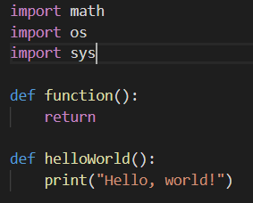

* For File I/O, the os and sys libraries are useful for identifying available files in a given directory, and identifying paths
* os.curdir is returns the path to the current working directory (the location in your computer where your python is located)
* os.listdir creates a list of files in a specified location (if using os.curdir it will create a list of all files in the current directory)

